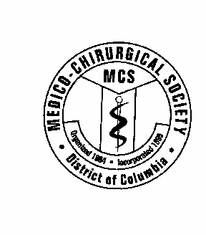

The Medico-Chirurgical Society of the District of Columbia

1308 Monroe St. #408

Washington, DC 20010

202-394-3960

November 23, 2020

Mayor Muriel Bowser

[Mayor@dc.gov](mailto:Mayor@dc.gov)

[eom@dc.gov](mailto:eom@dc.gov)

Dear Mayor Bowser:

I am writing to encourage you to support Bill BS23-0171, “Minor Consent for Vaccinations Amendment of Act 2020.” This bill was passed by the DC City Council by a vote of 10 to 3 on November 17, 2020 and is now scheduled for Mayoral Review. The bill permits a minor, 11 years of age or older, to consent to receive a vaccine in accordance with the Advisory Committee on Immunization Practices’ (ACIP) recommended immunization schedule. It also establishes that if a minor is able to comprehend the need for, the nature of, and any significant risks inherent in the medical care then informed consent is established.

For the children of our city, passage of this bill is a matter of health equity. It is common for children from low-income, working families to be brought for medical checkups by non- custodial family members (grandparents, aunts, siblings) while their parents are working. Minor consent will allow these children to access life-saving vaccines, so they don’t fall behind on their shots and out of compliance with school vaccination mandates simply because their parents can't take time off from work. Additionally, under existing DC law, minors aged 12 years and older already can consent to a wide range of medical procedures and care, including contraceptive services, mental health, prenatal care, abortions, and drug treatment. This bill would simply extend that care to vaccinations for ages 11 years and older.

Opponents of this bill will inaccurately claim it was designed to circumvent parental rights. For those of us actually providing medical care to families in the District, it is clear that this bill will provide assistance to some of our neediest families and eliminate some of the logistic barriers preventing them from providing the healthcare that they want for their children and that their children deserve.

I encourage you to support bill B23-0171 so that all children in the District have access to vaccinations.

Sincerely,



Melvin W. Williams, M.D.

President, Medico-Chirurgical Society of the District of Columbia